TCSS502

Assignment 3: Dungeon of Doom!

Output File

Dee Torco

Kishan Vekaria

Jeff Stockman

Dungeon Creation:

* 1) Create a maze (the game allows you various levels of difficulty / sizes of mazes), 2) remove walls by traversing to 100% of rooms, then 3) add items
* Verify ability to start at entrance, traverse to all pillars, and find exit
  + If not, dungeon_adventure will recreate a new dungeon
  + The way the maze is designed should prevent traverse from ever being false

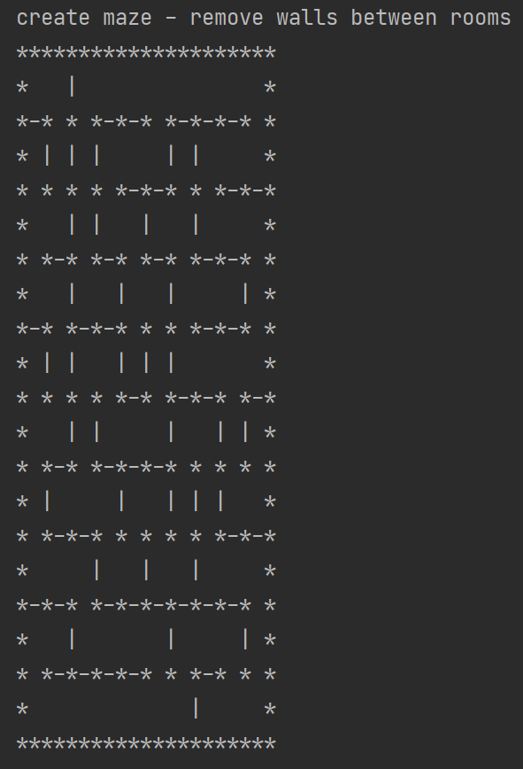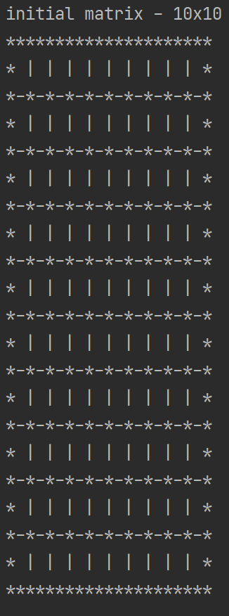

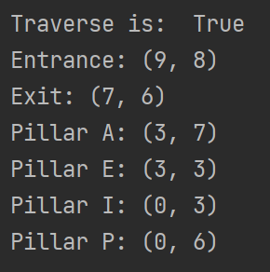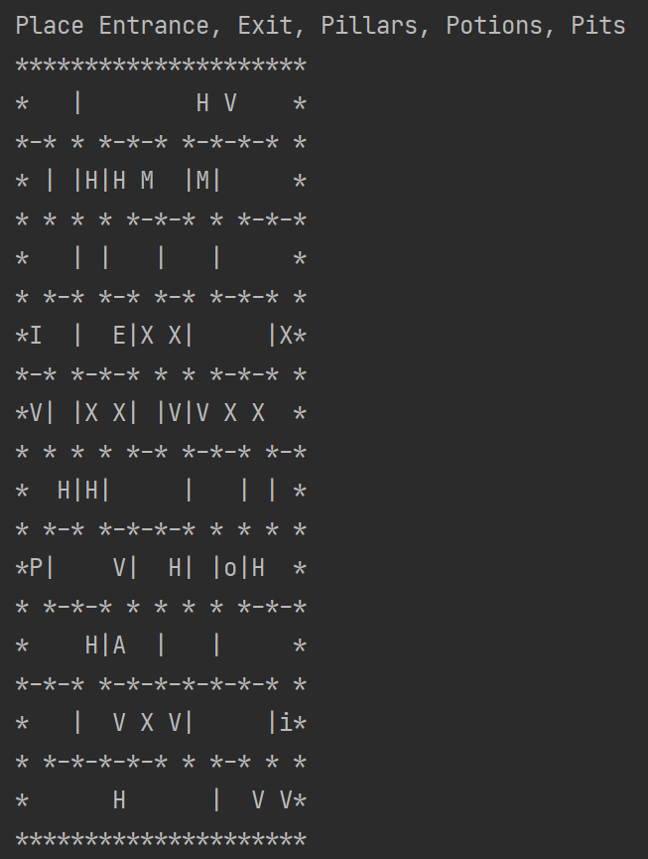

Playing the Game:

Finding all Pillars (Adventure status – use user_input command “s” in dungeon_adventure:

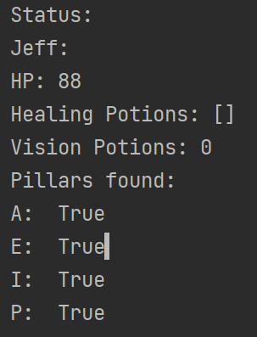

Finding exit after you have all four pillars:

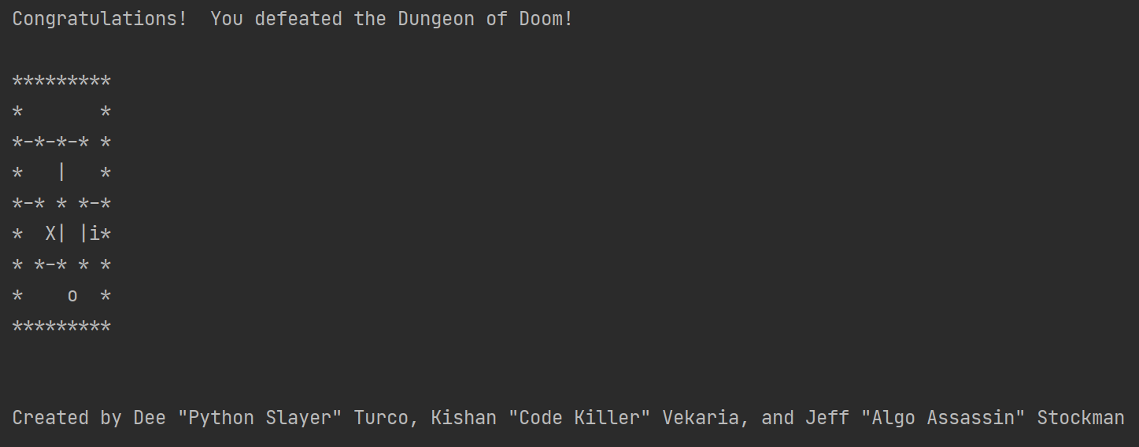

Falling to your death:

